# Configuring Azure AD Application for Excel Addin Sample

Login to portal.azure.com . Select Azure Active Directory.

Select App registrations. Click New Registration.

Provide a Name . For Supported account types , select the option as shown in snapshot. Click Register.

Make note of Application (client Id). Select Add a Redirect URL.

Replace all instances the boilerplate app id with the new app id noted above.

Select Add a Platform. Select option Single-page application.

Add – <https://localhost:3000/login.html> as Redirect url . Select Configure.

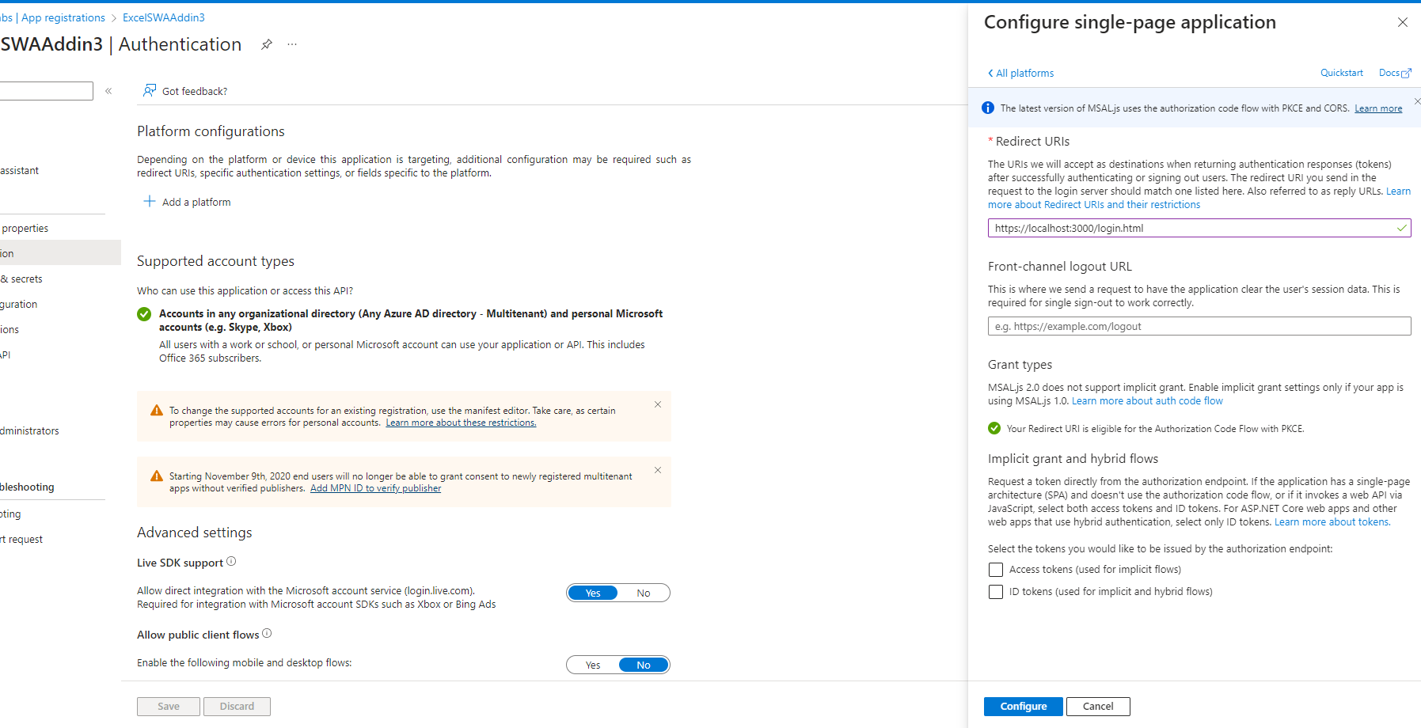

Repeat the same process for the following urls:

<https://brave-beach-05fccac0f.3.azurestaticapps.net/login.html>

<https://brave-beach-05fccac0f.3.azurestaticapps.net/login.html>

<https://localhost:3000/taskpane.html>

https://localhost:3000/fallbackauthdialog.html

Please note: In place of https://brave-beach-05fccac0f.3.azurestaticapps.net , replace the url of the statsi web app where you deploy your addin.

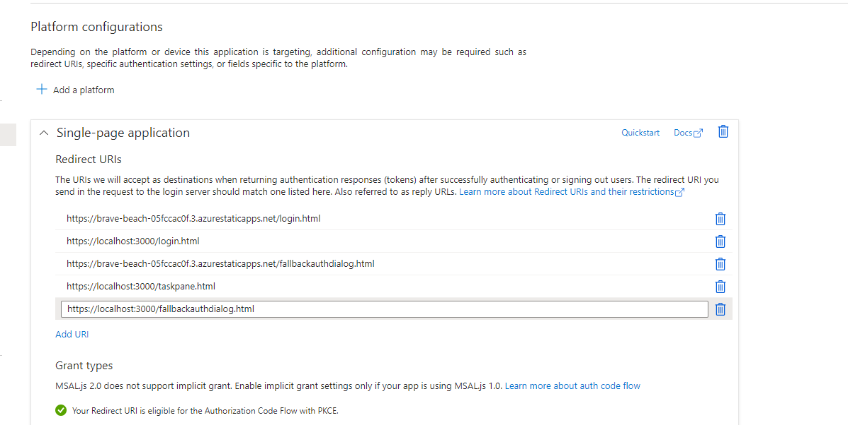

Open the sample swa addin code . Open login.js. replace the clientId with the client Id of your new application.

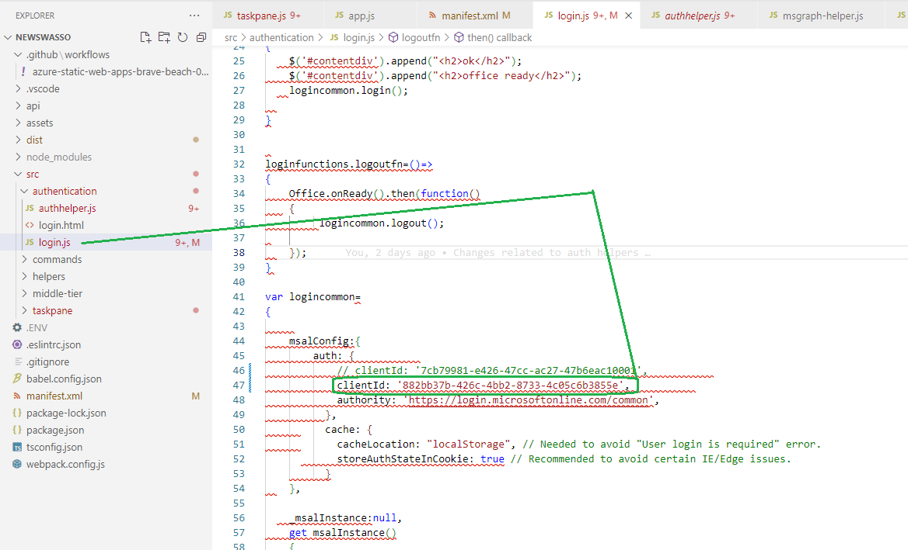

Make sure required permissions have been granted to the application. For this sample default MS Graph permission of User.read in sufficient.

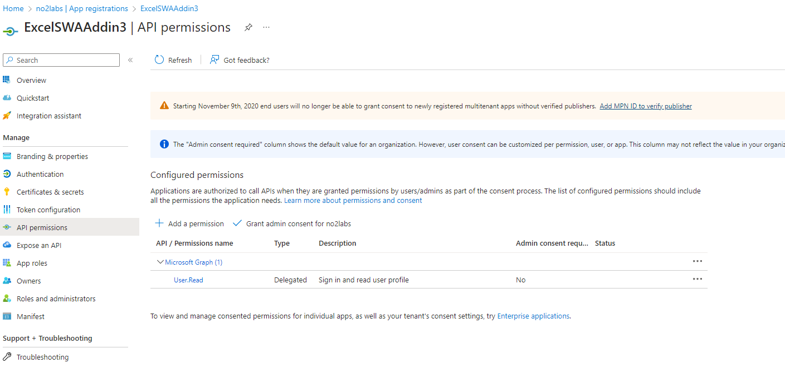

Publish your application to github which will publish it to your SWA.